The LOC Recruitment
Website Posting Template

*Note: Details will be different for each researcher and for different studies, so the information filled in here is just an example to illustrate how the advertisement will appear to students
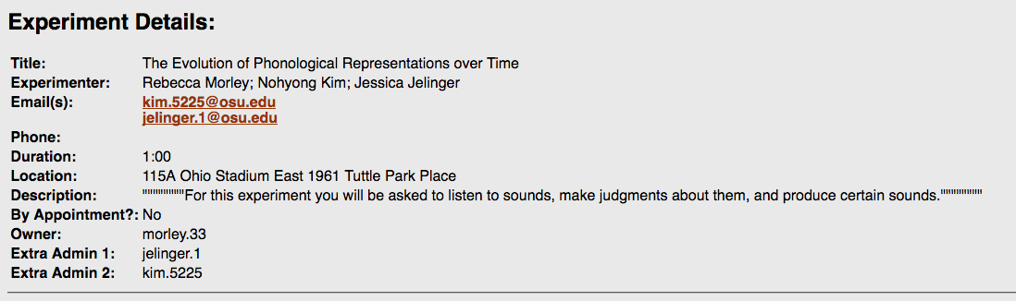

Please fill in information below
- Title of the study, list of experimenters (who will be collecting data) and their emails.

- Duration: Studies for LOC (that count as 1 LOC activity) are generally expected to be completed within an hour. If the experiment takes more than an hour, state that participation in the study may earn students 2 LOC credits if their instructors agree.

- Study location (Building and the room number). If there is a designated wait area, insert a brief explanation.

- Short study description determined by individual researchers

