*Note: Details will be different for each researcher and for different studies, so the information filled in here is just an example to illustrate how the advertisement will appear to students
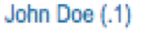
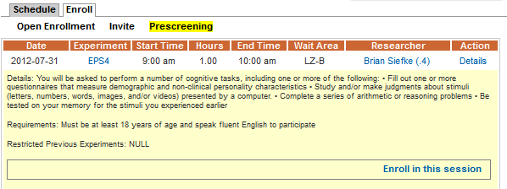
1.
2.
3.

Please fill in information below
- Details - Study description determined by individual researchers
Text:

- Requirements - Requirements for participation as determined by individual researchers
Text:

- Hours – Determined by individual researchers to reflect number of REP hours the participant will receive for participation, to be consistent with what is stated in the consent form
Text:

