C-REP Recruitment Website Posting Template
Use this template when preparing C-REP recruitment materials for the IRB. The screenshot below shows roughly what the announcement looks like. Your study details must be provided below that.
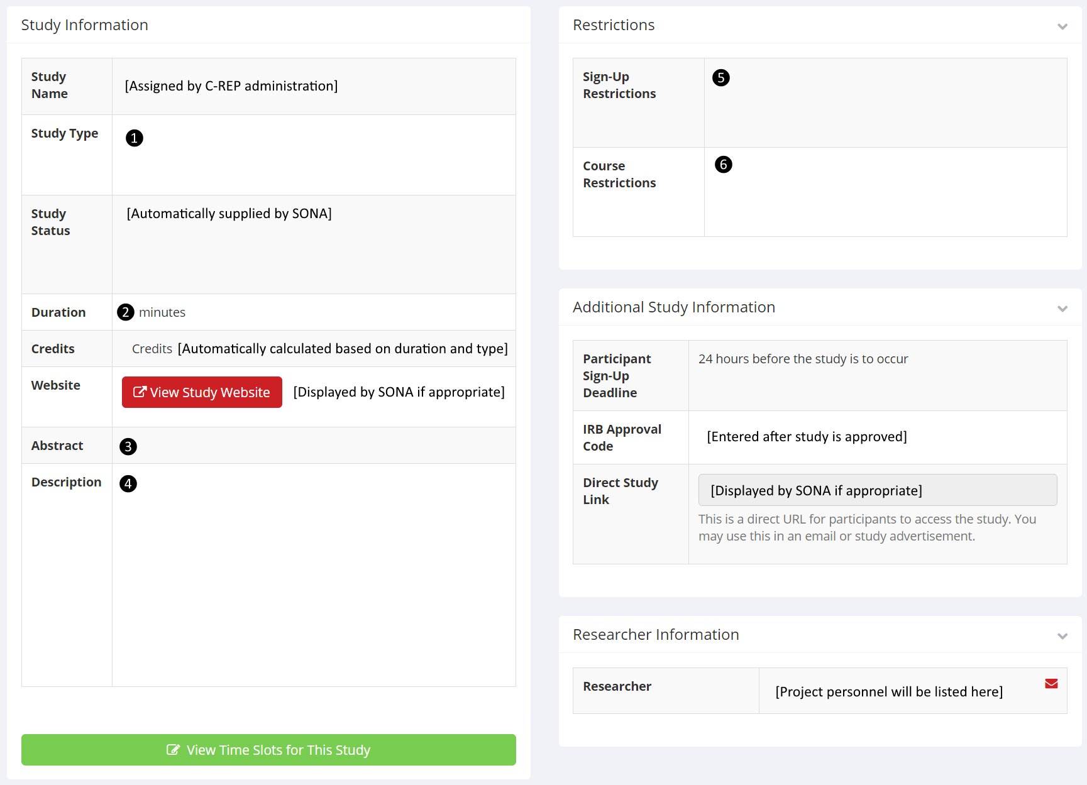
Please fill in the information describing your study in the space below. If the field does not apply to your study, please type N/A below the line.
- Study type: online or lab based?
[Leave only the selected type here; delete these instructions and the unused type]
- Duration (in minutes): Estimated time required to complete study. This estimate must match what is stated on the study consent form.

- Abstract: Short study description prepared by researchers.

- [Optional] Description: Extended study description prepared by researchers.

- [Optional] Sign-up restrictions: Participation requirements as determined by researchers.

- [Optional] Course restrictions: Participation requirements as determined by researchers.

